Dissemination and Exploitation Plan

(Draft)

Project title | Legal clinics in service of vulnerable groups: enhancing the employability of law students through practical education
Project acronym | ENEMLOS
Project reference – grant  agreement No. | 610449-EPP-1-2019-1-ME-EPPKA2-CBHE-JP
Coordinator | University of Montenegro
Project started date | 15 January 2020
Project duration | 36 months

Reference No. and title of the work package | 6. Dissemination and Exploitation Plan / WP 6
Leading Institution | University “Kadri Zeka” Gjilan
Supporting partners | All partners
Author(s) | UKZ supported by all partners
Document status | Working document
Document version and date | 2020
Dissemination level | Internal

Project number: 610449-EPP-1-2019-1-ME-EPPKA2-CBHE-JP
"This project has been funded with support from the European Commission. This publication reflects the views only of the author, and the Commission cannot be held responsible for any use which may be made of the information contained therein"

Contents
Dissemination and Exploitation Plan 1
Acronyms. 3
- Introduction 4
  - Purpose 4
  - Dissemination 4
  - Communication in the project context… 5
  - Requirements in terms of dissemination 6
  - Visibility of the European Union and of the Erasmus+ Programme 7
- Dissemination Strategy 8
  - Overview 8
  - Dissemination objectives… 9
  - Target groups… 10
  - Key messages… 11
  - Dissemination tools… 12
    - ENEMLOS Logo… 13
    - ENEMLOS Website 14
    - Social Network Profile 15
    - Project brochure 16
    - Other promotion materials… 17
    - Erasmus+ project results platform 20
    - Webpages of consortium members… 21
    - Targeted written material 22
- Calendar of dissemination events… 23
- Distribution of tasks and responsibilities… 29
- Monitoring and evaluation 32
Annex I – News form 33
Annex 2 – Event Report Form 36
Attachments… 38

Comment: The number of pages will change and will be corrected when we have the final document.

Acronyms
EACEA Education, Audiovisual and Culture Executive Agency EU European Union
HEIs Higher Education Institution

Faculty of law UoM
Supreme court of Montenegro
Bar Association of Montenegro
The State Prosecutor’s Office of Montenegro
Notary chamber of Montenegro
Chamber of Judicial Officers of Montenegro
Center for mediation
Basic Court Gjilan
Faculty of Law University of Zagreb
Regent’s University London (RUL)
Kosovo Bar Association
The Polish Legal Clinics Foundation
University of Pristina "Hasan Pristina"
Public University "Kadri Zeka"
Public University “Haxhi Zeka”

Introduction
  - Purpose

This document was developed as part of the ENEMLOS project – Legal clinics in service of vulnerable groups: enhancing the employability of law students through practical education co-funded by the Erasmus+ Programme of the European Union under grant agreement no. 610449-EPP-1-2019-1-ME-EPPKA2-CBHE-JP. This document represents the Dissemination and Exploitation Plan of the project, which incorporates a detailed description of the relevant activities and expected deliverables.

  - The Dissemination and Exploitation Plan belongs to Work Package 9 (WP6) – Dissemination and Exploitation.

The main purpose of the Dissemination and Exploitation Plan is to provide guidelines the project’s partners throughout Work Package 6 aiming to:
    - help partners better understand WP6 goals and their individual responsibilities,
    - give consortium members a clear idea of how to communicate the project’s goals, progress and results through the most appropriate tool to selected audience targets, in a timely manner,
    - help partners better understand the importance of their coordination, regarding the implementation of timely dissemination.

Dissemination

Dissemination is one of the core activities of the Legal clinics in service of vulnerable groups: enhancing the employability of law students through practical education project to ensure successful performance of planned activities and for project transparency, visibility and sustainability. The activities related to dissemination will start from the very beginning of the project – and will continue during its realization and after its completion as a permanent process which is important to raise the awareness of establishment and successful development of legal clinics structures in Montenegro and Kosovo partner universities.

At the beginning, the project website and social network site (Facebook) will be developed in order to make the project visible in social networks, and ensure that the information is regularly updated during the whole life cycle of the project.

The D&E plan will include information about the organization and holding of a wide range of promotional and informative events (such as open hours during the meetings; workshops or educational activities; institutional, local, national or international promotions, participation at professional gatherings, etc.) aiming to promote the project significance and its results.

Also, the D&E plan is going to be developed and implemented according to the significance of dissemination activities under the Erasmus+ projects guidelines: “Having a strong plan for dissemination and exploitation from the beginning of a project is a key priority and should form an integral part of the CBHE throughout its lifetime. The objective of dissemination and exploitation is to maximize the impact of project results by optimizing their value, strengthening their impact, transferring them to different contexts, integrating them in a sustainable way and using them actively in systems and practices at local and international levels”, (Erasmus + Programme, 2018, p.8).
In general, the Dissemination and Exploration Plan aims to widen the dissemination of knowledge, information and guidance. It includes a wide range of activities, tasks and events aiming to spread information about the project, and to exploit the results in the best and most professional way. Dissemination plan extends beyond project life; the long-lasting usage of project results is secured by careful planning of methods and means which will be used for dissemination.

Communication in the project context

The general goal of this project is to introduce mechanisms and skills in initial teacher education institutions in Kosovo to implement internal quality assurance practices that lead towards enhancement of quality of the graduates that are capable of driving school reform forward. Increasing the quality of teacher education graduates in Kosovo has the potential to influence everlasting changes in school practice which have been acknowledged as necessary in Kosovo school system. Changing teacher practice to reflect the new professionalism implies the need to develop teacher education institutions that are oriented towards improvement and monitoring the achievement of those targets to close the significant gap between current teacher practice realities in schools and the demanded teacher professionalism as reflected in current local policy set up and European level references.

- At the Faculty of law UoM several aims and objectives have been recognized.
- Modernization and streamlining of the existing teaching practice, especially in practical legal disciplines;
- Enhancing the overall capacity (human, technical and other resources) of the law faculties involved to provide quality legal education based on best European practices in clinical legal education
- Establishing new mechanisms of cooperation, i.e. interlinking of the higher education institutions involved, which will result with similar initiatives and activities in the future;
- Providing strong incentive for the higher education institutions involved, and particularly so in case of UoM Faculty of Law, to establish long-term sustainable cooperation with judiciary, National Prosecutor’s office and number of professional associations. Enabling students to gain practical knowledge through practical experience. Practical educational component is indispensable as a background tool for students’ primal knowledge on judiciary and related fields and their first encounter with the challenges of the real practice.

The project expects to achieve these objectives through the implementation of five interconnected WPs. WP6 (Dissemination) runs in parallel with the other WPs over the project lifetime, and focuses on defining a comprehensive and consistent project dissemination strategy, which will ensure maximum project visibility its results during and beyond the lifetime of the project. Project visibility will be achieved by:

- utilizing as varied tools as possible (including, but not limited to: website, social networks, dissemination material, organization of student and staff mobilities, establishing of expert network, organization of innovation and scientific conferences, collaboration with other projects funded under Erasmus+ CBHE Programme through the inter-project coaching),
- accurately strategizing the use of each tool to target a specific audience segment, in order to maximize the tool’s potential, creating a distinctive visual, graphic identity which partners will use to ensure a consistent image of the project across its dissemination material, thus allowing the wider public to better recognize and understand the project.
Dissemination of results is an integral part of the ENEMLOS project throughout its lifetime: from the initial idea, during the project and even after European funding has ended.
Therefore, the dissemination activities at different stages of the project cycle are:
- Before the project starts- drafting the dissemination plan, definition of the expected impact and deliverables, consideration of how and to whom dissemination outcomes will be disseminated,
- During the project- contacting relevant media e.g. at local or regional level, conducting regular activities such as training, study visits, mobilities, assessing the impact on target groups, involving other stakeholders in view of transferring results to end users/new areas/policies,
- At final report stage- uploading the final project results and an update of the project description on the Erasmus+ Project Results Platform,
- After the project- continuing further dissemination, developing ideas for future cooperation; evaluating achievements and impact, contacting relevant media, contacting policy-makers if relevant, cooperate with the European Commission by providing useful inputs to its dissemination and exploitation efforts.

Requirements in terms of dissemination

Dissemination is one of the award criteria on which the application will be assessed. A detailed and comprehensive plan, describing targets, tools and outcomes will be requested and further assessed. Although generally one partner will take the responsibility for dissemination and exploitation coordination for the whole project, the responsibility for implementation should be shared among all partners. Each partner will be involved in these activities according to the needs and roles in the project. That is stated in Partnership Agreements.

Visibility of the European Union and of the Erasmus+ Programme

Beneficiaries shall always use the European emblem (the 'EU flag') and the name of the European Union spelled out in full in all communication and promotional material. The name of the Creative Europe programme can appear with the flag. ’’This means that all material produced for project activities, training material, projects websites, videos and social media accounts created to promote the project, special events, posters, leaflets, press releases, CD ROMs, etc. must carry the Erasmus+ logo and mention: "Co- funded by the Erasmus+ Programme of the European Union".

Erasmus+ logo: Logo to be used:

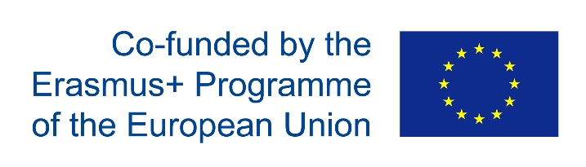

The following disclaimer shall be added to the inner pages of the publications and studies written by external independent bodies with support from the European Commission:
"This project has been funded with support from the European Commission. This publication [communication] reflects the views only of the author, and the Commission cannot be held responsible for any use which may be made of the information contained therein’’

In addition to the Dissemination Plan, partners should also consider the relevant European Commission documents(https://eacea.ec.europa.eu/sites/eacea-site/files/guidelines_for_the_use_of_the_grant_2017_cbhe_v_ii_-
_09_january_2018_0.pdf), including:

    - Guidelines for beneficiaries and other third parties,
    - Guidelines on studies and publications co-financed by the European Commission.

Dissemination strategy
  - Overview
The dissemination strategy defines clear guidelines for the dissemination activities including all operational elements of dissemination. Project results will be disseminated to the relevant target groups with appropriate content and on time. The content, timing and frequency of the various dissemination activities are defined in the present strategy. Dissemination strategy of the project consists of five core components (Figure 1):
- Objectives of dissemination: identify the project dissemination objectives;
- Target groups: identify crucial target groups and bodies that are interested in the
- project;
- Key messages: identify core project messages for specific target groups;
- Dissemination methods: identify dissemination methods, tools and channels;
- Dissemination time plan: identify a plan of dissemination activities.
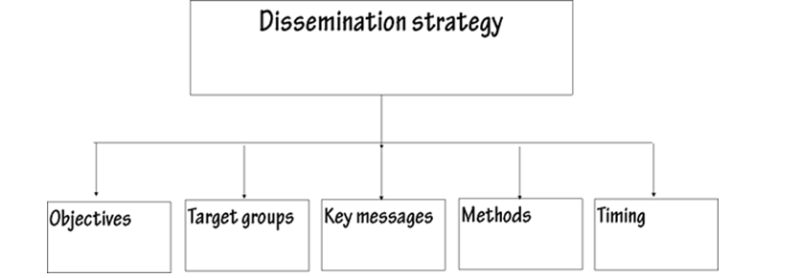
Figure 1. Dissemination strategy.

The project will use various actions in order to ensure high project visibility and maximal impact. Project dissemination will involve institutional, national and international activities. It will be focused on promotion the project and its participants and to raise awareness of the public about the potential benefits of the project results. One of the first tasks is creating this document at the very beginning of the project with intention to update it regularly throughout the project. Other important activities to be performed at the beginning of the project are also to define project's visual identity (logo) and design and print promotional material (flyers, posters, etc.) that will be distributed during the project’s life span.

Besides, the project website is developed and maintained (regularly updated with new information). The function of the website is to inform all target groups about the project realization and achieved results. Project participants can exchange documents via Google drive.
Social networks are utilized to spread the information about the project to the experts in the field (using LinkedIn) and to reach student population (using Facebook and Twitter). The awareness campaign will include advertising on TV, radio and newspapers. Special attention will be paid to promoting new courses in Higher Education Institutions (HEIs), which will be taught in English language. The promotions for structures with partner HEIs will be organized in order to promote the project. All events will be documented and displayed on the project website. Dissemination of the project outcomes will be carried out also through the existing and prospective study programs of all the HEI’s involved in this project.
In the long-term perspective of the project it is necessary to increase the awareness in Legal clinics in service of vulnerable groups: enhancing the employability of law students through practical education. This goal will be achieved mainly through the distribution of brochures, leaflets and booklets aimed to provide all relevant project information to interested stakeholders, as well as to publish information about ENEMLOS in mass media.

Dissemination objectives

The main aim of the dissemination strategy is a dissemination, transfer and exploration of knowledge among the project partners as well as to the interested stakeholders in the field of law in legal clinics. The dissemination objectives of ENEMLOS projects are to:
- Identify target groups at university level and different territorial levels: national, regional, EU;
- Identify the communication needs of the target groups;
- Establish core messages of the project, to be disseminated to the target groups;
- Identify dissemination methods and tools;
- Disseminate the results, solutions and knowledge collected within a project to the general audience;
- Define timing of dissemination activities;
- Define partners’ responsibilities in dissemination activities.

While defining the purpose of the dissemination, the first step is to decide on the audience, message, method and timing of the dissemination. The main purpose of ENEMLOS dissemination activities is to achieve involvement of all relevant stakeholders and to provide updated information of project results.

The dissemination activities will be therefore focused on:
- Raising awareness by informing general audience about the project work.
- Sharing information on the best practices on Legal Clinics.

Target groups

To achieve the best possible results during the project realization and its dissemination, the target groups which could be affected by project results should be identified. The primary goal of ENEMLOS project is to provide relevant and actual information to different stakeholders for possible approaches and ways to transfer theory to practice through established specific bodies.
The scope of the project and the importance of mentioned activities results in a variety of target groups:

- students,
- teaching staff,
- researchers,
- administration staff,
- stakeholders related to Law and judicial system and
- private and public sectors of Judicial System in Montenegro and Kosovo
- Professional and branch organizations
- Governmental institutions (relevant ministries, agencies, etc.)

At local level, all target groups will be reached by dissemination tools such as delivering promotional materials to students and citizens, the project website, social and digital media. This kind of informing will raise the awareness about the importance of improving the field of Legal Clinics.
At institutional level each of the Montenegro and Kosovo partner HEIs will enrich their educational potential in the field of International cooperation and project management

At European level, Montenegro and Kosovo partner HEIs will benefit the rich experience of EU HEIs in the field of law and practice. The teaching staff will be involved into the mobility trainings into EU partner countries through the study visits. The EU partners will be also in position to apply their knowledge to the specific cases in Montenegro and Kosovo, enriching in that way their experience.

Key messages

Once the purpose and audience of the dissemination are clear, the key messages can be defined. The principle guidelines of key messages are to:
- Be clear, simple and easy to understand. The language should be appropriate for the target audience, and non-technical language will be used where possible;
- Tailored to the target groups. It is of paramount importance to carefully consider what they should know about the project. It is possible to send the same message to different audiences, but the relevance of the message to the target group should be revised each time;
- Information should be correct and realistic.

The key messages are:
- Development of legal clinics
- Enhancing the employability of law students through practical education

The following key words will be used in dissemination materials:
- Legal Clinics.
- Increasing capacities.
- EU funded project
- Higher Education institution

Dissemination tools

Different documents and promotional materials have been designed and printed for the purpose of dissemination of the ENEMLOS project. For the communication between consortium members and other parties interested in the project activities, the project’s web site and Facebook page are used. For the purpose of project management, partners are using special online platform named Project Management Platform.

Table 3. Dissemination tools and responsible partner.
Dissemination tool | Description of  dissemination tool | Responsible partner | Participating  partner
Dissemination plan | Definition of content, timing, distribution  channels and responsible partner for each dissemination activity | UKZ | All partners
Brochure | Contains the main project information, consortium, will be used on every event for promotion of the project | UoM | All partners
Official website | Official ENEMLOS  website, with incorporated content and updated project information and deliverables. | UoM | All partners
Logo | Graphic brand word  mark prepared for visual identification | UoM | All partners

 | and project presentation.
Workshops | Dissemination through events & other activities | UoM and UKZ | All partners
Study visits and trainings | Study visits and trainings of ENEMLOS | EU partners | All partners
Conferences | Conferences organized on topic of innovation and employment | UoM | All partners

ENEMLOS logo

During the Kick Off Meeting, from the several proposals of ENEMLOS project logo designed, the below version has been decided as the final logo:

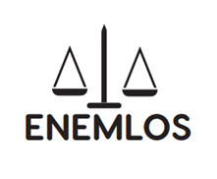

Figure 2. ENEMLOS logo.

ENEMLOS website

The ENEMLOS project website (https://www.enemlos.ucg.ac.me/) is an important dissemination tool for presentation of project results as well as place where all the information on the project activities and other relevant data are being published. Among the information related to the project description, objectives and outcomes of the project, the website also contains the list of the Consortium Members with their short presentations, as well as Logical Framework Matrix (LFM) and Work plan documents.
Structure of the ENEMLOS project website consists of 8 categories:

- HOME
- ABOUT (Description, Objectives, Lead partner, EU members, PC members, Associated partner)
- ENEMLOS PROJECT (Overview, Strategies & plans, Work packages)
- DISSEMINATION & ACTIVITIES
- DELIVERABLES
- RESULTS
- GALLERY
- CONTACT US
  - To social media accounts: Facebook, Instagram, twitter, YouTube channel, etc.
  - Websites of all the partners and Erasmus+

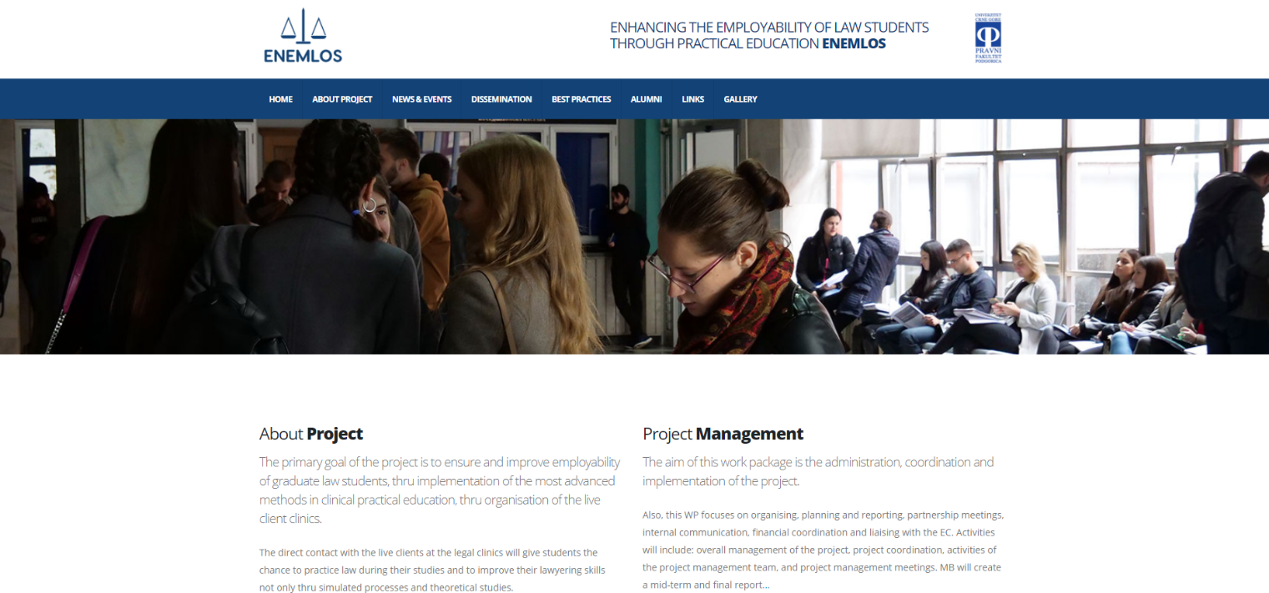

Figure 3. ENEMLOS webpage. https://www.enemlos.ucg.ac.me/

Social network profile

Social networking is the major tool that students today utilize to communicate with each other and to be informed on current issues. For this reason, social media will be utilized to access and engage future targeted students into ENEMLOS activities.

The project is active on Facebook (https://www.facebook.com/ENEMLOS/)

Figure 4. ENEMLOS Facebook page.
Facebook is the most widely utilized social network in the world. Through the ENEMLOS Facebook page, information, events, pictures and links can be shared, and the public can react by “liking” the page, giving “likes” to single elements and writing directly to the Project account

Project brochure

Project brochure is designed with idea to present briefly main information about ENEMLOS project to potentially interested parties. Text in the brochure gives short info on the type of the project, partners involved, main and specific objectives as well as the goals.

Figure 6. ENEMLOS Project brochure.

Figure 7. ENEMLOS Project Poster

Other promotional material

The most important print material for project promotion is the project brochure, designed to briefly present objectives and outcomes of the project. Other print materials (pencil, poster, rollup, folder, notebook, bag. ID Cards) are designed for the use during project events (workshops, trainings, conferences).

Figure 8. Pen

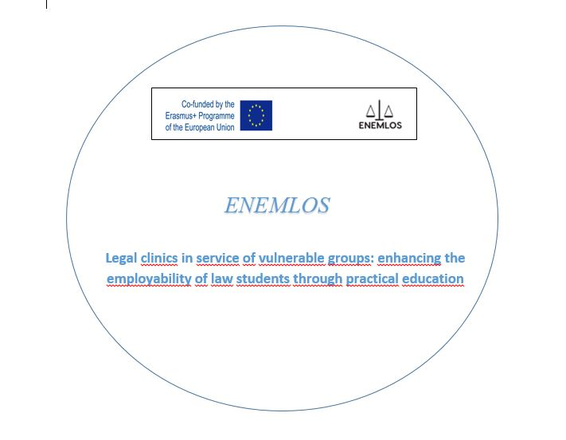

Figure 9. ENEMLOS PIN

Figure 10. Rollup

Figure 11. ENEMLOS Notebook

Figure 12. ENEMLOS folder

Figure 13. ENEMLOS bag

Erasmus+ Project Results Platform
•

The Erasmus+ Project Results Platform
(http://ec.europa.eu/programmes/erasmus-plus/projects/) will enable to achieve wider visibility of project results. The platform also makes available products/deliverables/intellectual outputs which are the result of the projects funded.

The ENEMLOS project summary will consist of the following

- context/background of the project,
- objectives of the project,
- timeline of the project,
- number and profile of participants,
- description of activities; methodology to be used in carrying out the project,
- a short description of the results and impact envisaged; the potential longer-term benefits.

Web pages of consortium members (Sample)

The organizational websites will be used to disseminate results.

Please write your webpage, where the project is listed:

https://www.uni-gjilan.net/hulumtimet-dhe-projektet-nderkombetare/marrdheniet-me-jashte/ENEMLOS- 2/

https://www.gjyqesori-rks.org/

http://unhz.eu/

https://www.uni-pr.edu/

Targeted written material (Sample)

Targeted written material such as reports, articles in specialized press, newsletters, press releases, leaflets or brochures will be used to disseminate results.

http://www.erasmusplus.ac.me/?p=20932

https://www.ucg.ac.me/objava/blog/1263/objava/64415-odrzan-prvi-sastanak-u-okviru-enemlos-projekta-koji-treba-da-poboljsa-zaposljivost-buducih-pravnika-putem-prakse

Figure 15. ENEMLOS presented in online media -

Calendar of dissemination events
Table 1. The calendar of
WP ? | Project Task | D&E type | Starting  date | Estimated  end date | Target  groups | D&E level | Responsibility

Distribution of tasks and responsibilities

In order for the D&E plan to progress successfully, under WP6, the UKZ and other partners will distribute the task to all consortium members with appropriate content and on time and will cooperate closely with all of them in order to maximize the visibility of the project. The Work Package on dissemination includes the following main activities:

WP 6 Communication Strategy development
  - Project Brand and Marketing Plan development
  - Organization of promotional events
  - Organization of scientific and innovation conferences

Table 2 shows the distribution of tasks among consortium members regarding WP 6 activities.

Table 2. Distribution of tasks

Task | Description of task | Partner in charge
Promoting the Kick-off meeting; | The project partners are responsible for the promoting the information materials for the kick-off meeting (list of participants; meeting agenda; minutes of the meeting; etc). | Led by UoM, contributions from all partners
Project Management Workshop | The dissemination materials about the project management issues, as: project management lifecycle, project management procedure and scheduling (Tasks durations and dependencies, Activity network Activity timeline, Project Staffing, Project Costing, Allocation of Responsibilities, the Financial Rules for the Management of the Grant),  etc., was done to all project partners. | Led by UoM & UKZ, contributions from all partners

Design of the D&E Plan | This will include methods and tools for results of D&E including organization and holding of wide range of promotional and informative events aiming to spread project significance and results | Led by UKZ, contributions from all partners
Functioning of the education software; | The online platform will be installed as a multi- functional multimedia solution for conducting webinars, online presentations, meetings, web conferences, online trainings, and other forms of distance  education and business networking | All partners

Organization of promotional events | Preparing and organizing the promotional and informative events;  All partner institutions will engage in organization and holding of a range of promotional and informative events, with the aim to exploit project results (both as regular activities of partner HEI and as separate activities that are complementary to regular project activities);  Promotional form and stake holders involved;  These events include: organization of open hours for internationalization and project managing workshops in Programme Countries; presentation of new teaching materials (Book, Guidelines) at international book fairs; institutional promotions; etc. | All partners
Organization of conferences | Organizing and conducting the international conference;  One international conference will be organized in the third year of the project. The conference will be organized and hosted by UoM . | UCAsupported by all partners

Monitoring and evaluation

The project has an overall evaluation strategy to ensure the project quality, therefore the monitoring for dissemination is vital, since the impact of those activities contributes to the successful implementation of the project. It is important that this evaluation is carried out on a continuous basis, to ensure:
  - an effective impact assessment and update or redefinition of dissemination activities,
  - the quality of the dissemination carried out.

A D&E working team will comprise of a representative from each institution. It will be steered by the UKZ. They will meet at least once per month and co-create inputs needed for all promotional materials foreseen under the D&E plan. The D&E lead by the UKZ will submit an annual report to the Project Coordinator on the progress of implementation of the D&E plan.

The following monitoring and evaluation tools will be set up: Statistics on the usage, reach and engagement of the website and the social networks; and Monitoring of workshop, study visits and other relevant events.

All news and events will be presented and reported to the Project Coordinator using the forms in Annex 1 and Annex 2.

The evaluation of the news and events will done in accordance with tools presented in the Quality and Monitoring Plan.

Annex 1. – News form NEWS FORM1
Project title | Legal clinics in service of vulnerable groups: enhancing the employability of law students through practical education
Project acronym | ENEMLOS
Project reference number | 610449-EPP-1-2019-1-ME-EPPKA2-CBHE-JP
CBHE-JP Coordinator | University of Montenegro
Project start date | 15 January 2020
Project duration | 36 months

Project number: 610449-EPP-1-2019-1-ME-EPPKA2-CBHE-JP

"This project has been funded with support from the European Commission. This publication reflects the views only of the author, and the Commission cannot be held responsible for any use which may be made of the information contained therein"

1 This template has to be filled by ENEMLOS project partners for sending material for publishing, promoting, media to the coordinator, on e-mail address: dukagjin.leka@uni-gjilan.net; anetaspaic@gmail.com; biljana.djuricin@yahoo.com ; luljete.berisha@uni-gjilan.net

NEWS DESCRIPTIONS (Sample)

Date
Author
Institution
News title
News link | :
News Description
Send the form to coordinator: anetaspaic@gmail.com; biljana.djuricin@yahoo.com dukagjin.leka@uni-gjilan.net; and selim.daku@uni-gjilan.net |  | luljete.berisha@uni-gjilan.net

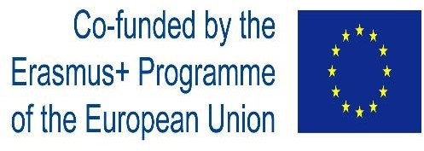

Annex 2 - EVENT REPORT FORM (Sample)

Project title
Project acronym | ENEMLOS
Project reference number | 610449-EPP-1-2019-1-ME-EPPKA2-CBHE-JP
CBHE-JP Coordinator | UKZ
Project start date | 15 January 2020
Project duration | 36 months

Event | Kick Off Meeting
Type of event | Kick Off Meeting and Workshop
Venue | Budva
Date | 23-25.02.2020
Organizer | University of Montenegro
Reporting date
Report author(s)

Number of participants at the event | 45 X 4 working days
Participants (organizations) | 15 consortium members, Erasmus + of ME
Event description:

Attachments

Agenda (pdf) | Title
Attendance sheet (pdf) | Title
Photos (jpg) | Title(s)
News form (pdf) | Title
Deliverable (pdf) | Title of document
Presentations (pdf) | Title(s)
Other personal remarks

